Ideation phase

# Literature Survey

|  |  |
| --- | --- |
| **TEAM ID** | PNT2022TMID17537 |
| **PROJECT NAME** | **A Gesture-based Tool for Sterile Browsing of Radiology Images** |

**A Gesture-based Tool for Sterile Browsing of Radiology Images**

# Abstract:

In this paper, we focus on using pointing behavior for a natural interface, Hand gesture recognition based human-machine interface. The use of doctor-computer interaction devices in the operation room (OR) requires new modalities that support medical imaging manipulation while allowing doctors' hands to remain sterile. This paper presents "Gestix," a vision-based hand gesture capture and recognition system that interprets in real time the user's gestures for navigation and manipulation of images in an electronic medical record (EMR) database. Navigation and other gestures are translated to commands based on their temporal trajectories, through video capture. "Gestix" was tested during a brain biopsy procedure. In the in vivo experiment, this interface prevented the surgeon's focus shift and change of location while achieving a rapid intuitive reaction and easy interaction. Data from two usability tests provide insights and implications regarding human- computer interaction based on nonverbal conversational modalities.

## Introduction:

Interactive presentation systems use advanced Human Computer Interaction (HCI) techniques to provide a more convenient and user-friendly interface for controlling presentation displays, such as page up/down controls of x-rays and relayed images in the medical field . Compared with traditional mouse and the interface for human-machine keyboard control, new experience is significantly improved with these techniques. Hand gesture has wide- ranging applications. In this study, we apply it to an interactive presentation system to create an easy-to-understand interaction interface.

## EXISTING SYSTEM:

In recent decades, the social life and information technology have a very close relationship in the twenty-first century. In the future, especially the interfaces of consumer electronics products (e.g. smart phones, games and infota1inment systems) will have more and more functions and be complex.

How to develop a convenient human machine Interface (Human Machine Interaction/Interface, HMI) for each consumer electronics product has become an important issue. The traditional electronic input devices, such as mouse, keyboard, and joystick are still the most common interaction way.

However, it does not mean that these devices are the most convenient and natural input devices for most users. Since ancient times, gestures are a major way for communication and interaction between people. People can easily express the idea by gestures before the invention of language. Nowadays, gestures still are naturally used by many people and especially are the most major and nature interaction way for deaf people. In recent years, the gesture control technique has become a new developmental trend for many human- based electronics products. The objective of this paper is to develop a real time hand gesture recognition system based on adaptive color HSV model and motion history image (MHI). By adaptive skin color model, the effects from lighting, environment, and camera can be greatly reduced, and the robustness of hand gesture recognition could be greatly improved.

## Problem Statement:

A major challenge involved is to provide Doctors with efficient, intuitive, accurate and safe means of interaction without affecting the quality of their work. However the use of computer keyboards and mouse by doctors in intensive care unit(ICU) is a common mean for spreading infections.We suggest the use of hand gestures in medical field as an alternative to the existing interface techniques by offering maximum level of sterility.

**Proposed System:**

The interaction with interventional imaging systems within a sterile environment is a challenging task for physicians. Direct physician–machine interaction during an intervention is rather limited because of sterility and workspace restrictions. We propose a method of gesture-controlled projection display that enables a direct and natural physician–machine interaction during computed tomography (CT)-based interventions.

Therefore, a graphical user interface is projected on a radiation shield located in front of the physician. Hand gestures in front of this display are captured and classified using a leap motion controller. We propose a gesture set to control basic functions of intervention software such as gestures for 2D image exploration, 3D object manipulation and selection. Our methods were evaluated in a clinically oriented user study with 12 participants.The results of the performed user study confirm that the display and the underlying interaction concept are accepted by clinical users. The recognition of the gestures is robust, although there is potential for improvements. The gesture training times are less than 10 min, but vary heavily between the participants of the study. The developed gestures are connected logically to the intervention software and intuitive to use. The proposed gesture-controlled projection display counters current thinking, namely it gives the radiologist complete control of the intervention software. It opens new possibilities for direct physician–machine interaction during CT-based interventions most importantly during surgeries carried out in ICU and is well suited to become an integral part of future interventional suites.

## Technical Architecture:

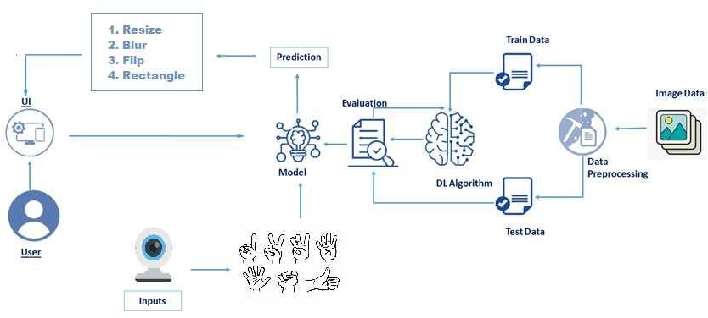

**Conclusion:**

The proposed work will help to eliminate the conventional methods of visualizing images in medical field. It only requires web-camera to capture I/P image. This would lead to a new generation of human computer interaction in which no physical contact with device is needed. Doctors, Nurses or any medical professionals can use the system to operate the computer easily, by using gesture commands.

## References:

1. Robust Part-Based Hand Gesture Recognition Using Kinect SensorZhou Ren, Junsong Yuan, Member, IEEE, Jingjing Meng, Member, IEEE, and Zhengyou Zhang, Fellow, IEEE, 15, AUGUST 2013
2. A Fast Gesture Recognition Scheme for Real-Time Human Machine Interaction Systems . Ching-Hao Lai* Smart Network System Institute for Information Industry Taipei City, Taiwan , 2010.
3. Intension, Context and Gesture Recognition for Sterile MRI Navigation in the Operating Room by Agency for Healthcare Research and Quality (AHRQ)
4. Hand Gestures Recognition Using Radar Sensors for Human-Computer- Interaction Supported by the Bio ad Medical Technology Development Program of the National Research Foundation(NRF)
5. A Preliminary Study of Kinect-Based Real-Time Hand Gesture Interaction Systems for Touchless Visualizations of Hepatic Structures in Surgery by Medical Imaging and Information Sciences, Jiaqing LIU, Tomoko Tateyama.
6. Vision Based Hand Gesture Recognition by World Academy of Science, Engineering and Technology, Pragati Garg, Naveen Aggarwal, Sanjeev Sofat.